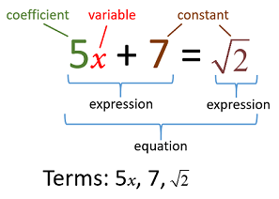

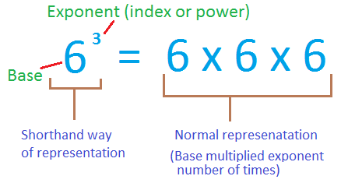

­­­­­­­­­­­­­­­­­­­++++++++++++++++++++++++++++++++++++++++++++++++++++++++++++++++++++++++++++++++++++

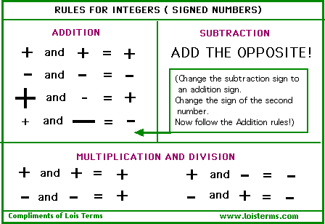

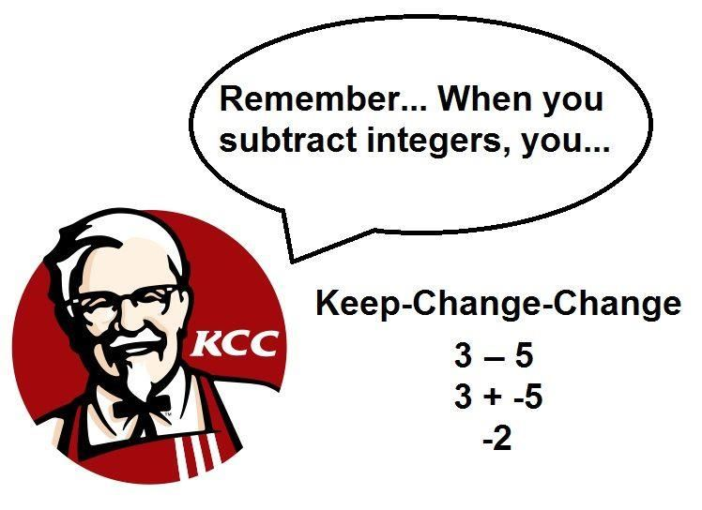

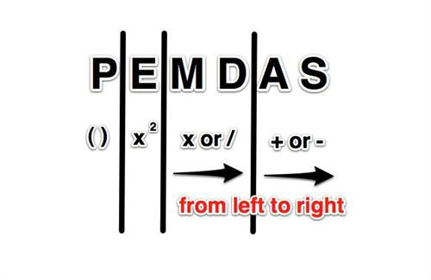

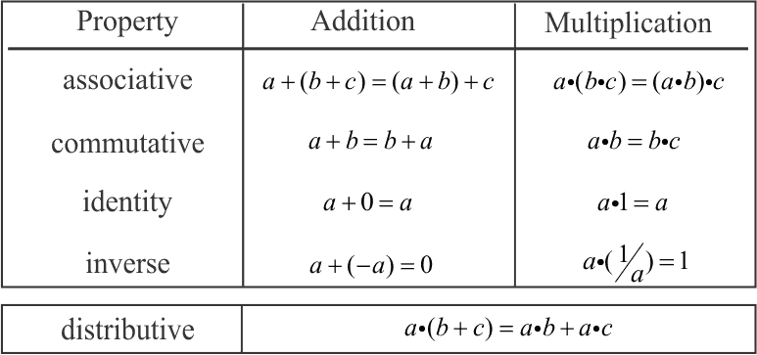

++++++++++++++++++++++++++++++++++++++++++++++++++++++++++++++++++++++++++++++

***What is a reciprocal?***

It is when the **Numerator** (top number) and the **Denominator** (bottom number) trade places

7

$\frac{5}{7}$ $\frac{7}{5}$

***Property of Reciprocals***

$\frac{2}{3 }$ $× \frac{3}{2}=1$